Chapter 18, Problem 43.

Find v_{o}(t) in the circuit of Fig. 18.45, where i_{s} = 5e^{-t} u(t) A.

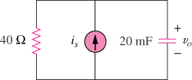

Figure 18.45
For Prob. 18.43.

